**Undergraduate Financial Assistance Fund 2023/24 Report**

The University’s Financial Assistance Committee provides a report following each academic year outlining the financial assistance provided to undergraduate students for the previous academic year. The following data is for the academic year 2023/24.

Please note that numbers of 5 and below are suppressed (<5) in order that individual students cannot be identified.

## **Contents**

1. Overview of the Fund
2. Application outcomes
3. Award values
4. Applications by College
5. Applications by fee status
6. Applications by course
7. Reason for financial difficulties (successful applications)
8. Reasoning behind unsuccessful applications

## **Overview of the Fund**

The Undergraduate Financial Assistance Fund provides financial assistance to undergraduate students in unforeseen financial need. The awards are intended to support students who would otherwise be unable to complete their course of study.

In 2023/24, the Fund provided awards of up to £2,500 to assist students with their living costs. The maximum award was reduced from the previous year’s exceptional increase of £3,500.

## **Application Outcomes**

In total in 2023/24 we received 162 applications. 16 were rejected due to the student not speaking to their college tutor before submitting the form. In total 64 applications were awarded. Of these, 3 applications were awarded after appeal. In total 5 applications were withdrawn by the student. 93 applications were rejected.

Figure 2a. Bar chart to show the breakdown of application outcomes received by term in 2023/24.

Figure 2b. Table to show the breakdown of application outcomes received by term in 2023/24.

|  |  |  |  |  |  |
| --- | --- | --- | --- | --- | --- |
|  | MT 2023 | LT 2024 | ET 2024 | LV 2024 | **Totals** |
| Award | 23 | 19 | 13 | 6 | **61** |
| Reject | 35 | 22 | 21 | 15 | **93** |
| Appealed and Awarded | <5 | <5 | <5 | <5 | <5 |
| Withdrawn by Student | <5 | <5 | <5 | <5 | <5 |
| Withdrawn by College | <5 | <5 | <5 | <5 | <5 |
| **Totals** | **61** | **44** | **36** | **21** | **162** |

Figure 2c. Pie chart to show the percentage spread of approval rate across terms in 2023/24.

Figure 2d. Table to show percentage spread of approval rate across terms in 2023/24.

|  |  |  |  |  |
| --- | --- | --- | --- | --- |
|  | MT 2023 | LT 2024 | ET 2024 | LV 2024 |
| Percentage awarded | 38% | 31% | 22% | 9% |

## **Applications by College**

Figure 4a. Bar chart to show number of applications by College in 2023/24.[1]

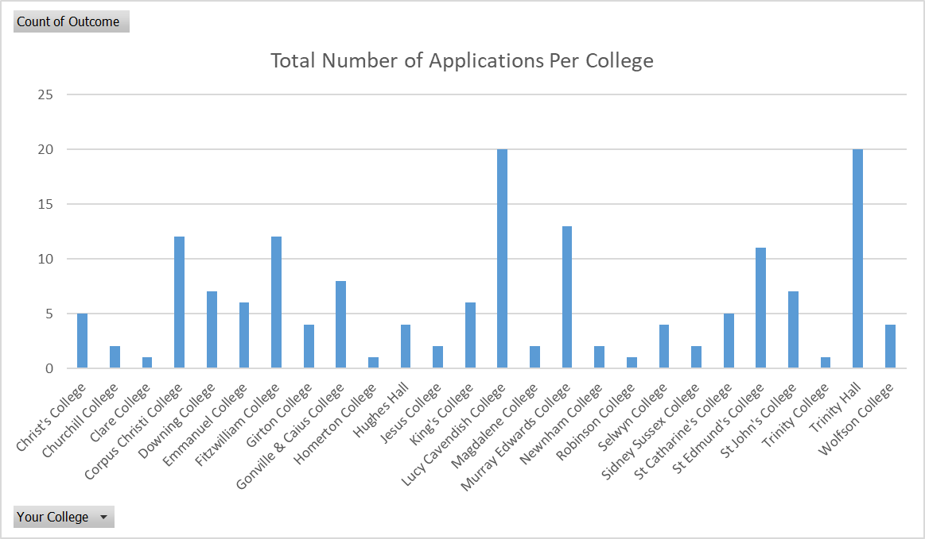

Figure 4b. Table to show breakdown of applications by College in 2023/24.

|  |  |  |  |  |
| --- | --- | --- | --- | --- |
| **College** | **Award** | **Reject** | **Withdrawn** | **Totals** |
| Christ's College | <5 | <5 | <5 | <5 |
| Churchill College | <5 | <5 | <5 | **<5** |
| Clare College | <5 | <5 | <5 | **<5** |
| Clare Hall | <5 | <5 | <5 | <5 |
| Corpus Christi College | <5 | 9 | <5 | **12** |
| Darwin College | <5 | <5 | <5 | <5 |
| Downing College | <5 | <5 | <5 | **7** |
| Emmanuel College | <5 | <5 | <5 | **6** |
| Fitzwilliam College | 6 | 6 | <5 | **12** |
| Girton College | <5 | <5 | <5 | <5 |
| Gonville & Caius College | <5 | 6 | <5 | **8** |
| Homerton College | <5 | <5 | <5 | **<5** |
| Hughes Hall | <5 | <5 | <5 | <5 |
| Jesus College | <5 | <5 | <5 | **<5** |
| King's College | 5 | <5 | <5 | **6** |
| Lucy Cavendish College | 8 | 10 | <5 | **20** |
| Magdalene College | <5 | <5 | <5 | **<5** |
| Murray Edwards College | <5 | 8 | <5 | **13** |
| Newnham College | <5 | <5 | <5 | **<5** |
| Pembroke College | <5 | <5 | <5 | **<5** |
| Peterhouse College | <5 | <5 | <5 | **<5** |
| Queens’ College | <5 | <5 | <5 | **<5** |
| Robinson College | <5 | <5 | <5 | **<5** |
| Selwyn College | <5 | <5 | <5 | **<5** |
| Sidney Sussex College | <5 | <5 | <5 | **<5** |
| St Catharine's College | <5 | <5 | <5 | **<5** |
| St Edmund's College | 7 | <5 | <5 | **11** |
| St John's College | <5 | <5 | <5 | **7** |
| Trinity College | <5 | <5 | <5 | **<5** |
| Trinity Hall | 7 | 13 | <5 | **20** |
| Wolfson College | <5 | <5 | <5 | **<5** |
| **Totals** | **64** | **93** | **<5** | **162** |

## **Applications by fee status**

Figure 5a. Bar chart to show breakdown of application outcomes by fee status in 2023/24.[2]

Figure 5b. Table to show breakdown of application outcomes by fee status in 2023/24.

|  |  |  |  |  |
| --- | --- | --- | --- | --- |
|  | Awarded | Rejected | Withdrawn | **Totals** |
| Home | 60 | 89 | <5 | **154** |
| Overseas | <5 | <5 | <5 | **8** |
| **Totals:** | **64** | **93** | **<5** | **162** |

## **Applications by course**

Figure 6a. Bar chart to show breakdown of application outcomes by course in 2023/24.

Figure 6b. Table to show breakdown of application outcomes by course in 2023/24.

|  |  |  |  |  |
| --- | --- | --- | --- | --- |
|  | Award | Reject | Withdrawn | **Total** |
| BA | 48 | 57 | <5 | **108** |
| MBBChir | 10 | 28 | <5 | **40** |
| MEng | <5 | <5 | <5 | **9** |
| VetMB | <5 | <5 | <5 | **<5** |
| MSci | <5 | <5 | <5 | **<5** |

## **Reason for financial difficulties (successful applications)**

The main reasons for the financial difficulties experienced by students with a successful application in 2023/24 were the following:

* Change to personal and living arrangements
* Student experienced a change to family circumstances
* Support relating to their year abroad and paid from year abroad fund
* Student from a country experiencing a crisis (e.g. Ukraine)
* Reduction in student finance
* Poor health
* Cost of Living Crisis
* Parents less/ not able to provide financial support
* Cash flow problems
* Collapse of funding plan
* Victim of crime

Figure 7a. Table of students awarded for each reason and spend

|  |  |  |
| --- | --- | --- |
| **Reason for financial difficulties** | **Number of Students awarded** | **Total Spend** |
| Poor Health | <5 | £5696.20 |
| Family Circumstances | 11 | £13,996.26 |
| Countries in Conflict/ Crisis | <5 | £5,000 |
| Cost of Living | <5 | £6,006 |
| Parents unable to provide support | 19 | £32,538.62 |
| Reduction in Student Finance | 7 | £11,186 |
| Year Abroad | 7 | £11,398.75 |
| Change to personal and living arrangements | 10 | £9041.41 |
| **Totals** | **63** | **£94,863.24** |

Figure 7b. Graph to show the number of students awarded per reason

## **Reasoning behind unsuccessful applications**

93 applications were unsuccessful with applications being declined due to not meeting the eligibility criteria of the Fund, as published on the webpages available on the Cambridge Students website. The main reasons include the following:

* No College tutor support form was submitted with the application
* Circumstances not unforeseen
* Clinical medic in 5th or 6th year and ineligible to receive funding
* Student considered to not be receiving a loan/ receiving enough loan and advised to apply to Student Finance for household income assessment
* High Shortfall
* Student recently started course and therefore ineligible
* Student applying for support with IT costs
* Student applying for support with Cost-of-Living crisis costs
* savings could cover shortfall
* Student applying for support with medical costs
* Student has high expenditure, above indicative living costs for 2023/24.
* Student is no longer a current, registered student
* Student has sufficient funding according to the indicative amount for 2023/24.
* Student applying for assistance to give money to family or friends
* Student applying for support with year abroad which is not unforeseen
* Student applying for support with intermission costs
* Student has already received maximum award for the year.
* Student does not have a shortfall

Figure 8b Table showing the number of students rejected per reason

|  |  |
| --- | --- |
| Reason for Unsuccessful Application | Number of Unsuccessful Applications |
| 5th/6th year clinical medic | 6 |
| Alternative funding plan required | <5 |
| Award limit reached or mitigated against | <5 |
| Change to personal or living arrangements | <5 |
| Circumstances not unforeseen | 11 |
| Cost-of-living Crisi | 12 |
| IT equipment costs | 7 |
| No college tutor support form | 16 |
| Not a current, registered student | <5 |
| Medical Costs | <5 |
| Student has spare income/savings | 8 |
| Student just started course | 6 |
| Student not taken out loan/full loan | 13 |
| **Total:** | **93** |

Figure 8b Bar Chart showing the number of students rejected by reason

1. Applicants state their College in the application form as it is needed to administer the application. However, as stated recently in Varsity:

   “The University Financial Assistance Fund does not screen by College, or prioritise one over another. It responds to requests on demand. In submitting an application, individual students need to have the support of their College tutor and declare whether they are in receipt of other sources of financial assistance (this may include separate hardship funds provided by their College). The University Hardship Fund doesn’t know whether an applicant is state or privately educated. It makes awards on the basis of individual need, and treats each application fairly.”
2. Please note that students are placed at no advantage or disadvantage if they are Home/UK or Overseas.